Lab 16 Managing Performance
This lab contains the following exercises and activities:
- Exercise 16-1: Viewing Resource Use in Windows Task Manager
- Exercise 16-2: Using the Performance Console
- Lab Review Questions
Scenario
Contoso, Ltd., uses servers of many types, including file servers, print servers, domain controllers, and application servers. In addition to the servers, of course, are many workstations.
Employee productivity is directly correlated with server and workstation performance, especially for employees who use computers frequently and access server resources. You have been asked by your supervisor to check the performance of various servers and workstations to see how they are performing, to identify where bottlenecks are decreasing performance, and to create a plan for increasing server and workstation performance where necessary.
To do this, you need to learn to audit computer performance using Task Manager, and, more importantly, the Performance console.
After completing this lab, you will be able to:
- Use Windows Task Manager to view resource use.
- Use the Performance console to monitor performance and set alerts.
- Configure virtual memory (paging files).
Before You Begin
You must have a drive L with at least 1.2 gigabytes (GB) of free space. Drive L was created in Exercise 3-1, "Formatting a Partition" and Exercise 3-2, "Converting FAT32 Partitions to NTFS." If you have not completed these exercises, either do so now, or substitute drive C for the paging file in Exercise 16-3, "Configuring Paging Files." The latter solution will make some of the exercise's inline questions invalid.
This lab uses the variable xx to refer to your number so that your computer name is referred to as Computerxx and your student identity as Studentxx.
You must switch from the Contoso domain to a Workgroup setting. The following steps will perform this process.
- From the start menu right click on My Computer and select Properties.
- Click on the Computer Name tab
- Click on the Change button
- In Member of select Workgroup and in the box type workgroup.
- Click OK
- When prompted enter Administrator in User name and none in password and click OK.
- Complete the process of restarting your computer.

Exercise 16-1: Viewing Resource Use in Windows Task Manager
You have just sat down at a Microsoft Windows XP system serving as a file server and want to see what resources it has available when it is largely idle, as it is now. To do so, you will use Windows Task Manager.
- Log on with your local Administrator account (the password is P@sswOrd).
- Right-click the taskbar and then select Task Manager.
- In Windows Task Manager, on the Performance tab, double-click the CPU Usage graph.
- Resize the CPU Usage and CPU Usage History graphs by dragging the right corner of the window in random directions for a few moments. This is intended to create CPU usage. Your graphs should look similar to the following figure.
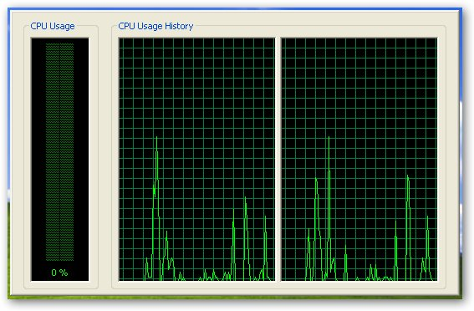
- Double-click inside the graphs to restore Windows Task Manager.
- Click the Processes tab.
- From the Start menu, point to All Programs, Accessories, and then select Tour Windows XP.
- In the Windows XP Tour dialog box, ensure that Play The Animated Tour That Features Text, Animation, Music, And Voice Narration is selected. Click Next.
- The Windows XP tour will begin. Notice that the CPU number for the entry for tour.exe on the Processes tab varies. The CPU number represents the percentage of processor cycles that are being dedicated to the Tour.exe process.
- Click on different areas of the tour and note the change in the CPU numbers.
- Close Windows Task Manager, and close the Windows XP Tour.
Exercise 16-2: Using the Performance Console
After briefly assessing system resources in Windows Task Manager, you want to better understand the performance of the file server. Specifically, you are interested in processor, memory, disk, and network interface loads. To assess these, you will use the Performance console.
The file server uses many disks to serve files (although your computer does not, so you will have to use your imagination). As a test, you want to send an alert using the Messenger service and create an entry in the Application log when a certain usage threshold is breached.
Adding Counters to the Performance Console
The following steps will add counters to the Performance console.
- From the Start menu, select Control Panel.
- In Control Panel, switch to Classic view if necessary. Double-click Administrative Tool.
- In the Administrative Tools window, double-click Performance.
- In the Performance console, in the console tree, ensure that System Monitor is selected.
- Click the X on the toolbar three times to delete the existing performance counters.
- Click the plus (+) icon on the toolbar.
- In the Add Counters dialog box, select Use Local Computer Counters.
- In the Performance Object drop-down list, select Processor.
- In the Select Counters From List list box, select % Processor Time.
- Click Explain.
Question 1: Summarize the explanation of the %Processor time counter.
- Ensure that % Processor Time is selected in the Select Counters From List list box, make sure that in Select instances form list is selected and that Total is highlighted, as shown in the following figure.
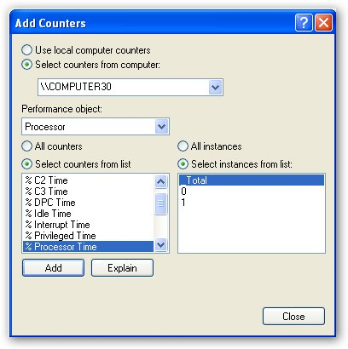
- Click Add
- Using the same technique as when you added the % Processor Time counter from the Processor performance object, add the counters listed in the following table for these three performance objects.
Question 2: As you add each Counter to the Performance counsel fill in the table below this one and add the explanation of what each counter measures.
Performance Object | Counter
Memory | Available Bytes
PhysicalDisk | % Disk Write Time
Network Interface (Note: When you add the Network Interface bytes Total/Sec counter, make sure you select the network interface card that is attached to the network in the Select Instances From List list box.) | Bytes Total/Sec

Counter | Explanation
Available Bytes
Bytes Total/Sec

- In the Add Counters dialog box, click Close.
- Leave the Administrative Tools window and the Performance console open.

Viewing Performance Statistics
The following steps will allow you to view performance counters while the computer is not idle.
- From the Start menu, point to All Programs, Accessories, System Tools, and then select Backup.
- If the Backup Or Restore Wizard appears, click Advanced Mode.
- In the Backup utility, on the Backup tab, in the directory tree, expand My Computer and then select the System State check box.
- In the Backup Media Or Filename text box, type L:\Test.bkf. Click Start Backup.
- In the Backup Job Information dialog box, select Replace the data on the media with this backup.
- Start Backup.
- Switch to the Performance console.
- Press CTRL + D to clear the display.
- After you have collected at least 30 seconds of data, press CTRL + F to freeze the display.
- Select the % Disk Write time counter in the counter pane, and then press CTRL + H to highlight the line in the graph representing the selected counter. An example of this is shown in the following figure.
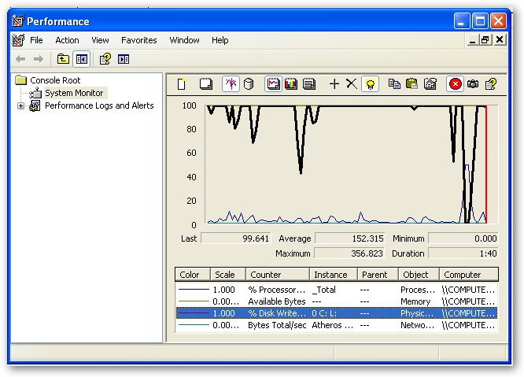
Question 3: What two system resources were taxed the most during the backup according to your data?
- Press CTRL + F
- Close all backup-related windows.
- Leave the Performance console open.

Sending Performance-Related Alerts
The following steps will configure the Messenger service to alert the Administrator account when a performance threshold is breached.
- In the Administrative Tools window, double-click Services.
- In the Services console, in the details pane, double-click Messenger.
- In the Messenger Properties (Local Computer) dialog box, in the Startup Type drop-down list, select Manual.
- On the Log on tab select Allow services to interact with desk top
- On the General tab click Start.
- The Service Control message box will appear and indicate progress.
- In the Messenger Properties (Local Computer) dialog box, click OK.
- Close the Services console.
- In the Performance console, in the console tree, expand Performance Logs And Alerts, and then select Alerts.
- From the Action menu, select New Alert Settings.
- In the New Alert Settings dialog box, in the Name text box, type Disk Time and then click OK.
- In the Disk Time dialog box, on the General tab, click Add.
- In the Add Counters dialog box, in the Performance Object drop-down list, select PhysicalDisk.
- In the Select Counters From List list box, select % Disk Time. Click Add, and then click Close.
- In the Disk Time dialog box, in the Limit text box, type 20.
- On the Action tab, ensure that the Log An Entry In The Application Event Log check box is selected, and select the Send A Network Message To check box.
- In the text box, type Administrator.
- On the Schedule tab, select Manually (Using The Shortcut Menu).
Tip: In a real-world situation, you could either start the scan manually, as we will do here, or schedule the scan to start at a time when you are concerned that the server will be especially busy.
- Click OK.
- In the Performance console, in the details pane check to see if the icon in front of the Disk Time is green, if not right-click Disk Time and then select Start. The icon should turn green.
- Leave the Performance console and the Administrative Tools windows open.
Triggering the Alert
The following steps will cause your computer to work hard enough to trigger the performance alert that you just configured.
- Open the Backup utility Advanced mode switch to the Backup tab.
- In the directory tree, select the System State check box. Click Start Backup.
- In the Backup Job Information dialog box, select Replace The Data On The Media With This Backup. Click Start Backup.
- In the Replace Data message box, click Yes to replace the data.
- You should receive an alert after a few moments
Question 4: What does the alert say?
- In the Backup Progress dialog box, click Cancel if the backup has not completed.
- If you cancel the backup In the Backup Utility message box, click Yes to cancel the backup.
- Close all backup-related windows.
- In the Messenger Service message box, click OK. There will probably be more than one; click OK in each.
- In the Performance console, in the details pane, right-click DiskTime and then select Stop.
- Leave the Performance console and the Administrative Tools windows open.
Viewing Alert Entries in the Application Log
The following will allow you to view an event logged in the application log due to breaching the performance alert that you configured earlier.
- In the Administrative Tools window, double-click Event Viewer.
- In the Event Viewer console, in the console tree, select Application.
- In the details pane, look for a recent event with the entry SymonLog in the Source column, and then double-click it.
Question 5: Fill in the following table with the information presented: Lab16/Fig12
Date
Source
Time
Event ID
Computer
Description

- Close all open windows.
Recording and Viewing Performance
On of the important things you want create is a performance baseline for the computer you are using. The following steps will show you how to create and view a computers performance over time.
- From the Start menu select Control Panel.
- In the Control Panel double-click Administrative Tools
- In the Administrative Tools double-click on Performance.
- Expand Performance Logs and Alerts.
- Click on Counter Logs.
- From the Action menu select New Log Settings.
- In the New Log Settings dialog box type Performance01 and click OK
- Add the following counters.
Performance Object | Counter
Processor | % Processor Time
Memory | Available Bytes
PhysicalDisk | % Disk Write Time
Network Interface (Note: When you add the Network Interface bytes Total/Sec counter, make sure you select the network interface card that is attached to the network in the Select Instances From List list box.) | Bytes Total/Sec

- Close the Add counters Window
- Under Sample data set the interval for every 15 seconds.
- Click on Log Files tab.
- In the End the name with drop down box select yyyymmdd.
- Click OK
- The performance01 Log should be running (indicated by a green icon (if it is not, right click on it and select start.
- From the Start menu select All Programs, Accessories, System Tools and Backup.
- From the Backup tab in the My Computer list select System Files.
- Click Start Backup.
- Make sure Replace the data on the media with this backup is selected.
- Click Start Backup
- Click Yes on the dialog box that appears.
- Run the backup to completion.
- Close all the backup windows
- Run various programs such as Microsoft word the Windows XP tour and searches on the Internet. Make sure that you leave all windows open as you do your work. Do this for about 20 minutes.
- Close all windows you have opened except for the performance monitor.
- Switch to the Performance window
- Right click on Performance01 and select Stop
- Click on System Monitor in the left pane.
- In the tool bar find the View Log Data button and click on it.
- On the source tab select Log file.
- Click on the add button.
- From the list select the Performance01 file with the current date.
Using the path information (c:\PerfLogs\Performance01_(currentdate), upload the file to D2L (20 points)
- Click Open
- Click OK
- View the log.
Question 6: What counter had the highest usage?
- Close all windows.
- Shutdown the computer.
Lab Review Questions
1. Task Manager has graphs that track to resources. What are they?
2. The Performance console by default monitors three performance counters. What are they?
3. A file server is becoming overloaded late in the afternoon, when the call center employees tend to get a lot of calls. You work the morning shift and are available during this time. How can you instruct the Performance console to gather data for you while you are away?
4. In what log does Event Viewer store log entries created by the Performance console Alert function?
Lab Challenge (30 extra points)
Create a performance log of your home computer. The performance log must be at least 2 hours long. Submit the log file to the D2l server for the extra credit.

